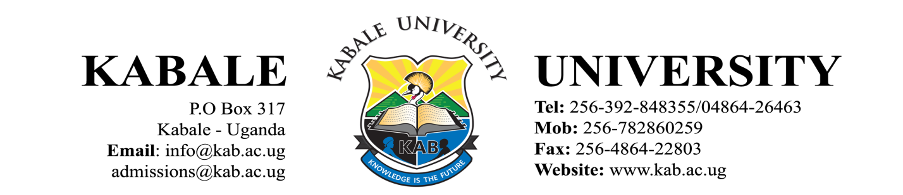

OFFICE OF THE ACADEMIC REGISTRAR

GENERAL STUDENT CIRCULAR

COMPLETION OF SEMESTER TWO 2019/2020 FOR STUDENTS IN THE SCHOOL OF MEDICINE

Greetings from Kabale University.

This is to inform you that teaching and learning activities will resume on Thursday 10th December, 2020 for Clinical Students and 4th January, 2021 for Pre-Clinical/Biomedical Sciences.

Clinical Students
This category of students will report for studies on 10th December, 2020 and belong to the following programmes:
- Bachelor of Medicine and Bachelor of Surgery (3rd year)
- Bachelor of Medicine and Bachelor of Surgery (4th year)
- Bachelor of Nursing Science – Direct Entry (3rd year)
- Bachelor of Nursing Science – Direct Entry (2nd year)

Pre-Clinical/Biomedical Sciences
This category of students will report for studies on 4th January, 2021 belong to the following programmes:
- Bachelor of Medicine and Bachelor of Surgery (1st year)
- Bachelor of Medicine and Bachelor of Surgery (2nd year)
- Bachelor of Nursing Science – Direct (1st year)
- Bachelor of Nursing Science – Completion (1st year)
- Bachelor of Nursing Science – Completion (2nd year)

Clinical Students reporting on 10th December, 2020 are required to:
- Come with at least four (4) reusable (cloth) masks.
- Come with two (2) clinical coats and two (2) aprons,
- Come with four (4) 60mls bottles of alcohol-based hand sanitizers for personal use.
- Come with two (2) pairs of scrubs.
- Attend training on COVID-19 Standard Operating Procedures (SOPS).

Please take note that the following Standard Operating Procedures put in place by the Ministry of Health shall be followed:
- Mandatory wearing of a face mask at all times.
- Social/physical distancing.
- Washing of hands regularly and/or sanitizing hands.

Please ensure that fees balances (if any) are cleared before examinations.

Stay safe.

Narcicir Tibenderana
ACADEMIC REGISTRAR 8th December, 2020

Cc: Vice Chancellor
Deputy Vice Chancellor – Academic Affairs
Deputy Vice Chancellor – Finance & Administration
University Secretary
University Bursar
Dean of Students
Dean, School of Medicine
Guild President

