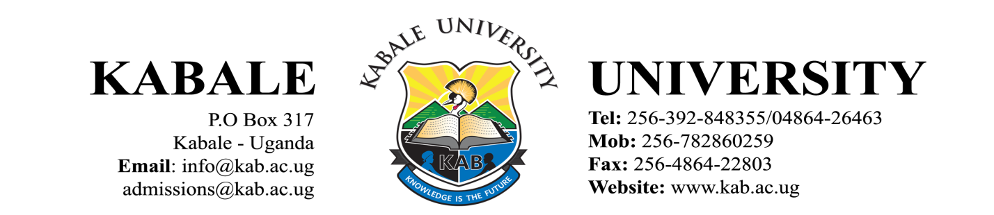

OFFICE OF THE ACADEMIC REGISTRAR

GENERAL STUDENT CIRCULAR

REPORTING FOR STUDIES FOR FIRST YEAR POSTGRADUATE STUDENTS –
12TH DECEMBER, 2020

Greetings from Kabale University.

Thank you for choosing Kabale University as your first choice Institution for your studies.

This is to inform you that reporting for orientation will be 12th December, 2020.

Given the prevailing circumstances, Technology has been adopted in teaching and learning as an enabling environment which ensures that the safety of students and staff against the COVID-19 pandemic is not compromised. In light of this, you are required to have Smart Phones Laptops, Ipads etc where you will download e-learning applications for use during online sessions.

The orientation programme will include registration and training on online studies. In order to register the students are expected to fulfill the requirements in the admission letters.

Looking forward to receiving you.

Further information will be communicated as and when necessary.

Stay Safe. Knowledge is the Future!
Narcicir Tibenderana
ACADEMIC REGISTRAR
Email: ntibenderana@kab.ac.ug
Tel: +256-772485496

Cc: Vice Chancellor
Deputy Vice Chancellor – Academic Affairs
Deputy Vice Chancellor – Finance & Administration
University Secretary
University Bursar
Dean of Students
Faculty Deans and Directors
Guild President

