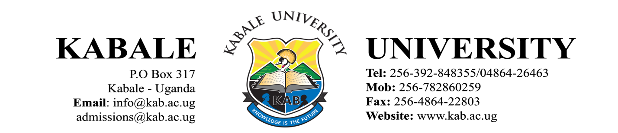

PRESS STATEMENT

RESUMPTION OF STUDIES FOR FINAL YEAR STUDENTS: 2019/2020 ACADEMIC YEAR

This is to inform all Final Year Students that teaching and learning activities which were halted in March, 2020 due to the outbreak of COVID-19 will resume on Monday 19th October, 2020.

You are therefore requested to report on Saturday 17th October, 2020.

You will be required to:
- Come with at least four (4) reusable (cloth) masks.
- Come with four (4) 50mls bottles of alcohol-based hand sanitizers for personal use.
- Attend training on COVID-19 Standard Operating Procedures (SOPS) to be conducted at the Main Campus (Kikungiri) on Monday, 19th October, 2020.

Please take note that the following Standard Operating Procedures put in place by the Ministry of Health shall be followed:
- Mandatory wearing of a face mask at all times.
- Social/physical distancing.
- Washing of hands regularly and/or sanitizing hands.

The duration of the remaining Semester is 8 weeks (6 weeks for teaching and learning and 2 weeks for examinations).

Narcicir Tibenderana
ACADEMIC REGISTRAR 8th October, 2020

